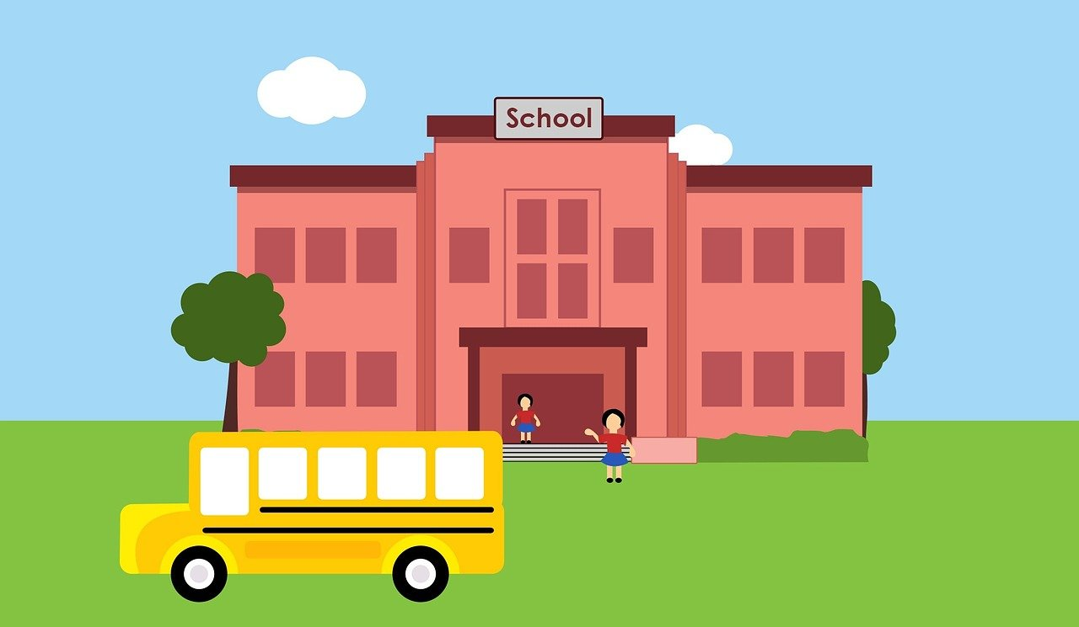
Nursery and Kindergarten

Welcome to Nursery/Kindergarten! My name is Nicole Freed, and I am so happy to be your child’s teacher this year! I have taught nursery and kindergarten for the last 8 years, and this is my first year teaching at Principal Sparling! I know we are going to have a wonderful year together full of learning and fun. Indigenous perspectives are embedded into our classroom and school through academic and social lessons. Manitoba First Nations Guide to support Early Learning states that “The term early learning encompasses all activities, experiences, and interactions that young children become involved in to expand their physical, emotional, social, cognitive, and spiritual areas of development. Children’s learning capacity is enhanced when their experiences are nurtured in a caring, safe environment and when they are able to explore the world through play, whether it is in the home, community, or other learning environment”. In nursery and kindergarten, we focus on the medicine wheel and the 7 teachings in all subject areas.
The Nursery and kindergarten program at Principal Sparling school is a play based, hands on learning program. The goal of nursery and kindergarten is to instill a love of learning in all students.
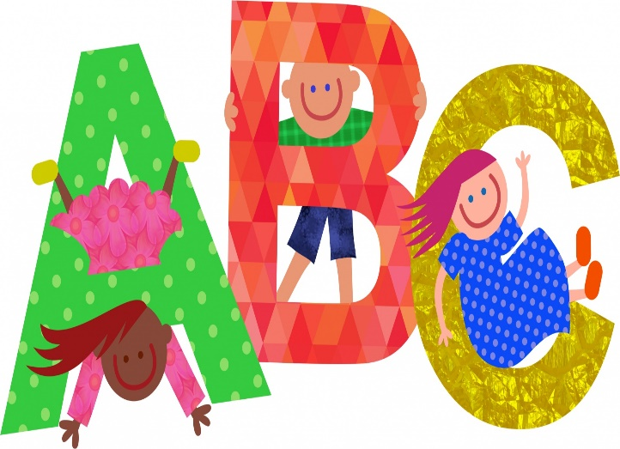

Our literacy program includes language development, phonological awareness, alphabet knowledge and early writing. We begin our literacy program focussing on letter recognition and letter sounds, as well as beginning and ending word sounds. We will move toward learning sight words and learning how to read. Students will work on forming letters correctly and printing their names. We will work on strengthening our hands through fine motor activities such as beading and using tweezers in our sensory bin and centres.
Students will learn how to use scissors correctly, and how to hold a pencil properly.
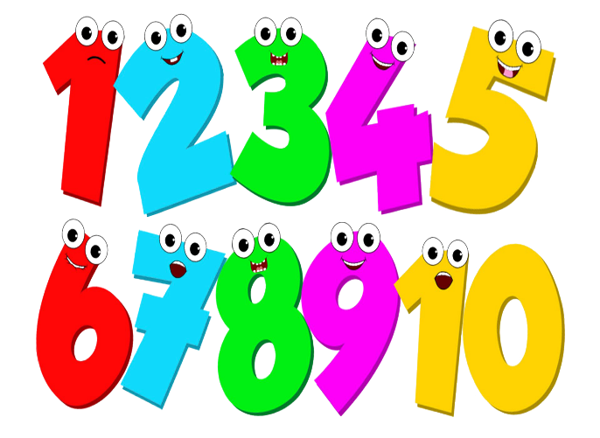

The nursery and kindergarten mathematics program uses a developmental approach to building number sense. We will practice counting forward and backward daily at calendar and carpet time. We will work on patterning, comparing quantities, place value and making sets. These will be taught and practiced through classroom games and activities in both small groups and whole class activities.
Social and emotional learning is a big part of the nursery and kindergarten program. Students will learn about different feelings and emotions. We will practice turn taking, and sharing, and will learn what it means to be a good friend and a good community member through the 7 teachings and learning about being a bucket filler. We will learn strategies like belly breathing to help regulate our emotions.
We will learn about health and well-being by being active, and learning about taking care of our teeth, and making healthy food choices.
Music and movement are a very important part of our classroom! Not only are music and movement activities fun, but through music we learn about letters and letter sounds, rhyme, rhythm, and following directions. Please make sure your child is dressed for the weather. We love to play outside!
I am looking forward to spending the school year with your child learning, laughing, and having fun! Please do not hesitate to email me at nfreed@wsd1.org with any questions or concerns.
Thank you for your support,
Ms. Nicole Freed
