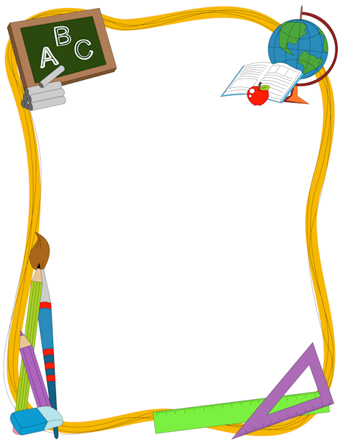

Room 8 Grades 2/3

Kevin Storey
kstorey@wsd1.org
204-775-2591

Welcome to a new school year! I am so excited to have your child in my class this year. We are going to have lots of fun this year with tons of learning and new adventures!

In Room 8 we will be learning and exploring English language arts, math, social studies, art, and health. In respect of our strong Indigenous community, we will involve Indigenous studies in all subject areas.

Here are the subject areas and topics your child will be learning this year.

Math
- Counting forward & backward from 0 to 100 by 1’s, 2’s, 5’s, and 10’s
- Representing numbers using the Draw It, Write It, Build It strategy
- Estimation up to 100 (grade 2) & 1000 (grade 3)
- Illustrate place value up to 100 (grade 2) & 1000 (grade 3)
- Addition & subtraction using 2 digit numbers (grade 2) & 3 digit numbers (grade 3)
- Multiplication up to 5x5 & corresponding division problems (grade 3)
- Describing, reproducing, extending, & creating patterns up to 100 (grade 2) & 1000 (grade 3)
- Addition & subtraction problems involving symbols representing an unknown number (grade 3)

English Language Arts
- Small group reading lessons using the Reading A-Z program
- Small group book studies
- Lessons focusing on phonics using the Words Their Way program as well as the TouchPhonics program
- Intensive writing program using the Lucy Culkin writing program
- Sight word awareness using Dolch Words and Fry Words lists
- Buddy reading program
- Home reading program

Science
- Growth & Changes in Plants & Animals
- Properties of Solids, Liquids, and Gases
- Materials & Structures
- Position & Motion
- Forces that Attract or Repel
- Air, Soil, & Water in the Environment

Social Studies
- Our local community
- Communities across Canada
- The Canadian community
- Exploring the world
- Communities of the world
- Exploring an ancient society

Art
- Using repetition and variety to create and modify art patterns
- Using symmetry in art
- Themed art projects based on school-wide celebrations
- Art projects focusing on science, ELA, math, and social studies lessons

Health
- Daily habits and responsibilities for leading a physically active and healthy life
- Focus on common communicable diseases and how to prevent them
- Proper dental care habits
- Canada Food Guide
- Importance of proper nutrition to support physical activity
- Family life lessons

I believe….
- Learning should be FUN!
- Learning should happen together in groups.
- Learning should happen with partners.
- Learning should happen through play.
- Kids should learn from each other.
- Kids should learn by completing hands on projects.

