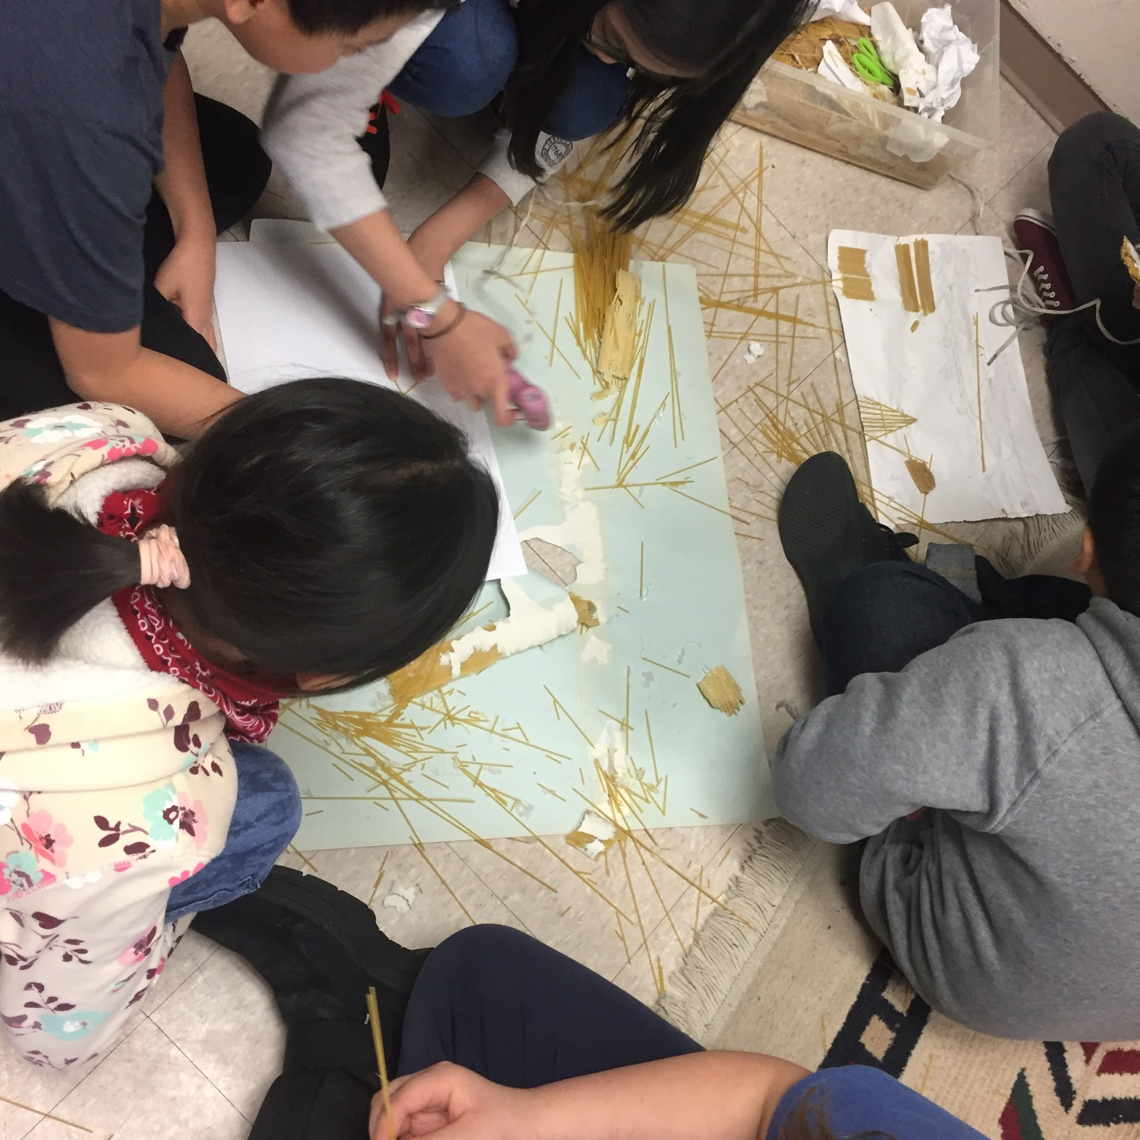  [Students develop their communication and collaboration skills in doing an engineering challenge]  Attendance  It is very important for your child to attend school on a regular basis. The children are responsible to complete all assignments that they have missed. Safe arrival will call you if your child is not in school at 9:00 and 1:00. This plan is in place for safety reasons. Please send a note if your child has a medical appointment and needs to leave school early.  Behavioural Expectations  Our expectations are: to try our best. respect ourselves and others, treat our property and school property with respect, follow class and school rules, and continue to be a role model. Students must complete class assignments and homework, listen when others are speaking, clean up after themselves, and have fun!! |  |  | Assessment Tools & Strategies  Students are assessed through: observations of daily performance. checklists and anecdotal notes, written assignments, tests and quizzes. Assessment is also completed through conferences, group work, student self-assessment, student self-reflection, and focusing on learning goals. Additional forms of assessment are through work samples, learning logs, portfolios, and demonstrations.  Who We Are  Wellington is a Nursery to Grade 6, community school based within the West Central neighbourhood.  There is mutual respect, honesty, responsibility and cooperation among all members of the school community.  Wellington School strives for all students to be fully equipped to meet the challenges of the 21st century - socially, emotionally, physically and academically to be active responsible citizens of the world.  Watch for updates at:  www.winnipegsd.ca  Contact Us:  204-774-8085 |  |  | Wellington’s Grade 5/6  PROGRAM OVERVIEW
English Language Arts  Our program covers the general outcomes of English Language Arts through activities in listening, speaking, reading, writing, viewing and representing.  The main goals for the students are to: explore thoughts, ideas, feelings and experiences, comprehend and respond personally, and critically to oral, literacy and media texts. Other goals are: to manage ideas and information, enhance clarity and artistry of communication, and to celebrate and build community.  Digital Literacy  Building technological competence and digital literacy is a priority in our teaching. We use technology to support all subject areas rather than teach it in isolation. |  |  | Mathematics  The major goals in mathematics are that the student should: use mathematics to solve problems, exhibit a positive attitude towards mathematics, and communicate mathematically. Other goals are to appreciate mathematics and its contributions to civilization, reason mathematically, commit oneself to lifelong learning, and become mathematically literate.  Make every second count!  Social Studies  This year, the Social Studies program consists of the study of: Building a Nation (1867-1914), An Emerging Nation (1914-1945), Shaping Canada (1945-present), Canada Today: Democracy, Diversity, & Influence of the Past.  Additionally, we focus on the rights and responsibilities of citizenship in Canada, and indigenous perspectives and voices to paint Canada’s history. |  |  | 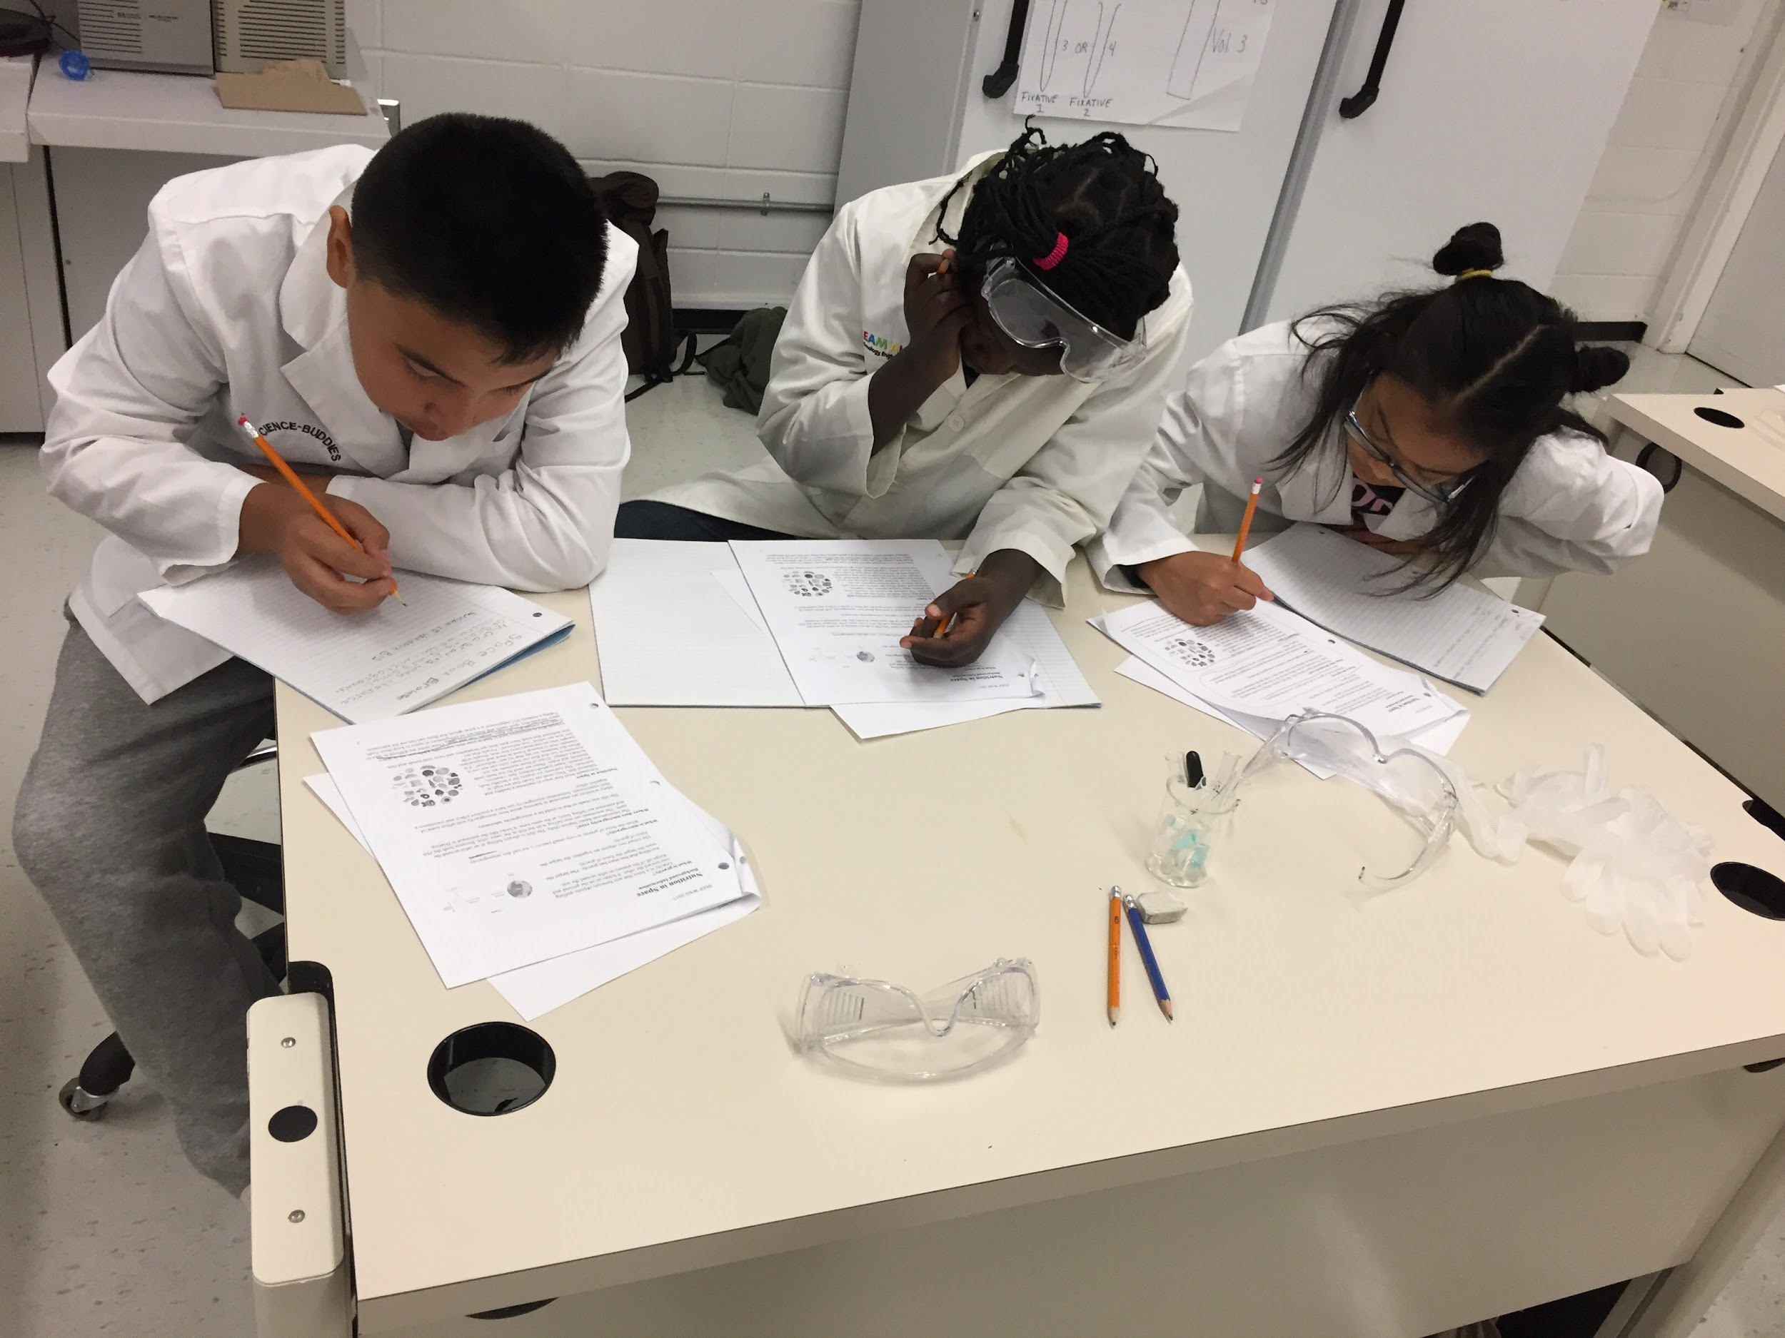  [Students learn science outcomes through experimentation]  Science  This year, the Science program focuses on four clusters which are: Diversity of Living Things, Flight, Electricity, The Solar System.  Our school has Science Fair and Knowledge Fair where students do research and experimentation to pursue an area of study that interests them.  Additionally, we integrate learning about the affects of Climate Change throughout the school year.  Health  The units covered in Health are: healthy lifestyles, personal safety and decision making, drug education, the family, and puberty and human reproduction.  Health objectives are taught throughout the school year including family life curriculum. We utilize mindfulness activities to help our students regulate their emotions and support their mental health.

