**HELP THE SPREAD OF GERMS**



DON’T STAND REALLY CLOSE TO PEOPLE



COVER YOUR MOUTH IF YOU COUGH

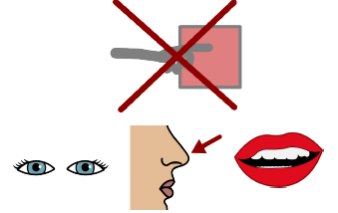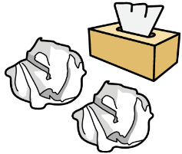

PUT YOUR TISSUE IN THE GARBAGE



DON’T TOUCH YOUR EYES, EARS AND MOUTH

WASH YOUR HANDS

Sing **Happy Birthday** 2 times!